Phylum: Nematoda
Class: Chromadorea
Order: Rhabditida
Family: Cooperidae
Genus: Cooperia

Cooperiosis
Cooperia
Host
Cattle, sheep, goats and other wild and domestic ruminants (deer, antelopes, camelids, etc.). They are also called the small intestinal roundworms.

Species
C. curticei, mainly in sheep and goats.
C. oncophora, mainly in cattle
C. pectinata, mainly in cattle
C. punctata, mainly in cattle
C. surnabada, cattle and sheep

Identification
C. oncophora females are about 6–8 mm long, males about 5.5–9 mm. They are light red in color and have a coiled shape. Male worms have a large bursa as shown in Figure 2a. The spicules are 240-300 µm long and have a rounded end and a longitudinal line pattern. L3 stage larvae are hard to differentiate between different species, because they are very similar interspecies-wise. Eggs of C. oncophora however can be easily identified by their parallel walls. They also have a nervous system but no excretory organs and no circulatory system, i.e., neither a heart nor blood vessels. Males have a rather large copulatory bursa two short and thick spicules for attaching to the female during copulation. The eggs are rather cylindrical with rounded ends and characteristic parallel walls. They are about 80 micrometers long and contain numerous cells when shed.

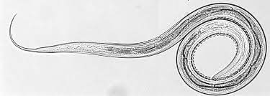
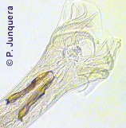

Life cycle
The life cycle of C. oncophora is direct. Free-living L3 stage larvae residing on the pasture are taken up by grazing cattle and pass to the small intestine. Here, they molt to L4 larvae and then to adults. Eggs are passed in the faeces to the pasture. The larvae hatch and grow to L3 stage larvae. Infective L3 stage larvae are then again taken up by grazing cattle and the life cycle repeats. The pre-patent period, which includes the time between infection and egg laying, lasts between two and three weeks. Like other trichostrongylids, early C. oncophora L4 larvae are able to arrest their development under unfavourable environmental conditions such as low temperatures and high dryness, a process termed hypobiosis. L4 larvae can stay arrested up to five months.

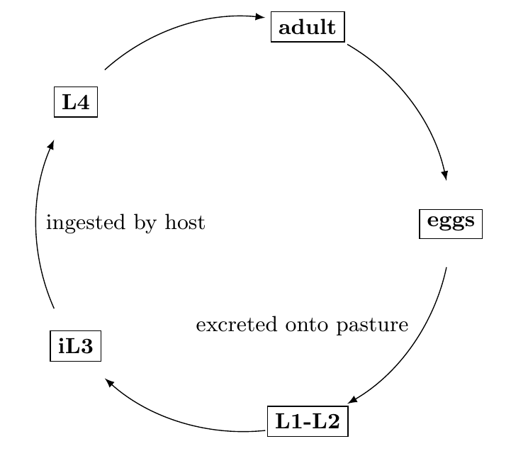

Pathogenesis
Cooperia are considered less pathogenic to livestock than other common gastrointestinal nematode worms. Typically, calves are affected most adversely. Infection causes appetite reduction and inefficient uptake of necessary nutrients which effects body weight, reproduction and can lead eventually to calf death. Although C. oncophora does not feed on host-blood, it has the capacity to burrow through the gut wall, especially in the proximal location (duodenum) which can lead to anemia in the host.

Clinical sings
Typical clinical signs are diarrhea (aqueous, green or black) with subsequent dehydration and weight loss as a consequence of poor food conversion. Other signs are the same as for other gastrointestinal roundworms: apathy, loss of appetite, reduced weight gains, etc. Massive infections are particularly harmful for young animals, which can become anemic. Since most infections are mixed with other gastrointestinal roundworms (e.g., Haemonchus spp, Ostertagia spp, Trichostrongylus spp, etc.) it is often difficult to ascribe the damage to Cooperia or to other worms.

Diagnosis
Diagnosis is based on the clinical signs and confirmed after detection of characteristic eggs in the feces.

Prevention and control of Cooperia infections
Being very resistant to adverse environmental conditions, Cooperia larvae can survive up to 12 months on pasture, which makes it quite difficult to reduce the populations. Or they spend the winter as dormant larvae. This ensures re-infection of the pastures during the next spring. A general rule, whatever reduces pasture contamination with infective larvae (e.g., adequate pasture rotation) or exposure of livestock to such larvae will diminish the impact on the herd. Such preventative measures are the same for all gastrointestinal roundworms and are explained in a specific article in this site. Livestock exposed to these worms often develop natural resistance progressively and may recover spontaneously. Such resistant animals do not become sick if re-infected, but continue shedding eggs that contaminate their environment. Numerous broad spectrum anthelmintics are effective against adult worms and larvae, e.g., several benzimidazoles (albendazole, febantel, fenbendazole, oxfendazole, etc.)

