Vaccines
Living and Killed Vaccines
Unfortunately, two of the prerequisites of an ideal vaccine— high antigenicity and absence of adverse side effects—are often incompatible.
Modified live vaccines infect host cells and undergo viral replication. The infected cells then process endogenous antigen. In this way live viruses trigger a response dominated by CD8+ cytotoxic T cells, a Th1 response.
This may be hazardous because the vaccine viruses may themselves cause disease or persistent infection (called residual virulence).
Killed organisms, in contrast, act as exogenous antigens.
They commonly stimulate responses dominated by CD4+ Th2 cells.
This may not be the most appropriate response to some organisms, but it may be safer.
It also appears that dendritic cells respond in a different fashion to live and killed bacteria. For example, live organisms such as salmonella upregulate more CD40, CD86, IL-6, IL-12, and GM-CSF than do killed organisms.
The practical advantages and disadvantages of vaccines containing living or killed organisms are well demonstrated in the vaccines available against Brucella abortus in cattle. B. abortus is a cause of abortion in cattle, and vaccination has been used historically to control the disease.
Brucella infections are best controlled by a T cell–mediated immune response, and a vaccine containing a living avirulent strain of B. abortus is required for the control of this infection.
Older live Brucella vaccines, especially strain 19, caused a lifelong immunity in cows and successfully prevented abortion.
Unfortunately, strain 19 vaccine also caused systemic reactions: swelling at the injection site, high fever, anorexia, listlessness, and a drop in milk yield. Strain 19 could cause abortion in pregnant cows, orchitis in bulls, and undulant fever in humans.
Because of the disadvantages associated with the use of strain 19, considerable efforts have been made to find a better alternative.
Unfortunately, killed vaccines (strain 45/20) protected cattle for less than 1 year. A live attenuated strain of B. abortus called RB-51 has been used in cattle in the United States.
The advantages of vaccines such as brucella strain 45/20 that contain killed organisms are that they are safe with respect to residual virulence and are relatively easy to store since the organisms are already dead (Box 23-2).
These advantages of killed vaccines correspond to the disadvantages of live vaccines,
such as strain 19 or RB-51. That is, some live vaccines may possess residual virulence, not only for the animal for which the vaccine is made but also for other animals.
They may revert to a fully virulent type or spread to unvaccinated animals.
Live vaccines always run the risk of contamination with unwanted organisms; for instance, outbreaks of reticuloendotheliosis in chickens in Japan and Australia have been traced to contaminated Marek’s disease vaccines.
A major outbreak of bovine leukosis in Australia resulted from contamination of a batch of babesiosis vaccine containing whole calf blood.

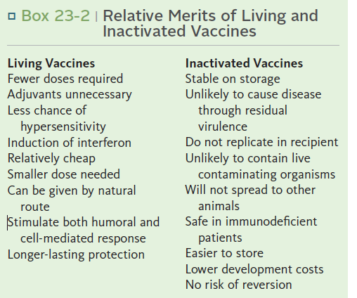

Finally, vaccines containing living attenuated organisms require care in their preparation, storage, and handling to avoid killing the organisms. Maintaining the cold chain can account for 20% to 80% of the cost of a vaccine in the tropics.
The disadvantages of killed vaccines parallel the advantages of living vaccines. The use of adjuvants to increase effective antigenicity can cause severe inflammation or systemic toxicity, whereas multiple doses or high individual doses of antigen increase the risk of producing hypersensitivity reactions, as well as increasing costs.
Inactivation
Organisms killed for use in vaccines must remain as antigenically similar to the living organisms as possible. Therefore crude methods of killing that cause extensive changes in antigen structure as a result of protein denaturation are usually unsatisfactory.
If chemicals are used, they must not alter the antigens responsible for stimulating protective immunity. One such chemical is formaldehyde, which cross-links proteins and nucleic acids and confers structural rigidity. Proteins can also be mildly denatured by acetone or alcohol treatment. Alkylating
agents that cross-link nucleic acid chains are also suitable for killing organisms since by leaving the surface proteins of organisms unchanged, they do not interfere with antigenicity.
Examples of alkylating agents include ethylene oxide, ethyleneimine,
acetyl ethyleneimine, and β-propiolactone, all of which have been used in veterinary vaccines. Many successful vaccines containing killed bacteria (bacterins) or inactivated toxins (toxoids) can be made relatively simply by the use of these agents. Some vaccines may contain mixtures of these
components. For example, some vaccines against Mannheimia hemolytica contain both killed bacteria and inactivated bacterial leukotoxin.
Attenuation
Virulent living organisms cannot normally be used in vaccines. Their virulence must be reduced so that, although still living, they can no longer cause disease. This process of reduction of virulence is called attenuation. The level of attenuation is critical to vaccine success. Underattenuation will result in residual virulence and disease; overattenuation may result in an ineffective vaccine.
The traditional methods of attenuation were empirical, and there was little understanding of the changes induced by the attenuation process. They usually involved adapting organisms to growth in unusual conditions so that they lost their adaptation to their usual host. For example, the
bacille Calmette-Guérin (BCG) strain of Mycobacterium bovis was rendered avirulent by being grown for 13 years on bilesaturated medium. The vaccine strain of anthrax was rendered avirulent by growth in 50% serum agar under an atmosphere rich in CO2 so that it lost its ability to form a capsule.
B. abortus strain 19 vaccine was grown under conditions in which there was a shortage of nutrients. Unfortunately, genetic stability cannot always be guaranteed in these attenuated strains. Back-mutation may occur, and attenuated organisms may redevelop virulence.
A more reliable method of making bacteria avirulent is by genetic manipulation. For example, a modified live vaccine is available that contains streptomycin-dependent M. hemolytica and Pasteurella multocida. These mutants depend on the presence of streptomycin for growth. When they are administered to an animal, the absence of streptomycin will eventually result in the death of the bacteria, but not before they have stimulated a protective immune response.
Viruses have traditionally been attenuated by growth in cells or species to which they are not naturally adapted. For example, rinderpest virus, which is normally a pathogen of cattle, was first attenuated by growth in rabbits. Eventually, a successful tissue culture–adapted rinderpest vaccine devoid of residual virulence was developed.
Widespread and systematic use of this vaccine eventually permitted the global eradication of rinderpest.
Similar examples include the adaptation of African horse sickness virus to mice and of canine distemper virus to ferrets. Alternatively, mammalian viruses may be attenuated by growth in eggs. For example, the Flury strain of rabies was attenuated by prolonged passage in eggs and lost its virulence for normal dogs and cats.
The traditional method of virus attenuation has been prolonged tissue culture. In these cases virus attenuation is accomplished by culturing the organism in cells to which they are not adapted. For example, virulent canine distemper virus preferentially attacks lymphoid cells.
For vaccine purposes, therefore, this virus was cultured repeatedly in canine kidney cells. In adapting to these culture conditions, it lost its ability to cause severe disease.
Under some circumstances it is possible to use fully virulent organisms for immunization just as the Chinese once did with smallpox. Vaccination against contagious ecthyma of sheep is of this type. Contagious ecthyma (orf ) is a viral disease of lambs that causes massive scab formation around the mouth, prevents feeding, and results in a failure to thrive. The disease has little systemic effect.
Lambs recover completely within a few weeks and are immune from then on. It is usual to vaccinate lambs by rubbing dried, infected scab material into scratches made in the inner aspect of the thigh. The local infection at this site has no untoward effect on the lambs, and they become solidly immune. Because the vaccinated animals may spread the disease, however, they must be separated from unvaccinated animals for a few weeks.

Modern Vaccine Technology
Although both killed and modified live vaccines have been successful in controlling many infectious diseases, there is always a need to make them more effective, cheaper, and safer(Figure 23-4). The use of modern molecular techniques can produce new and improved vaccines. These vaccines can be divided into several categories (Table 23-1).
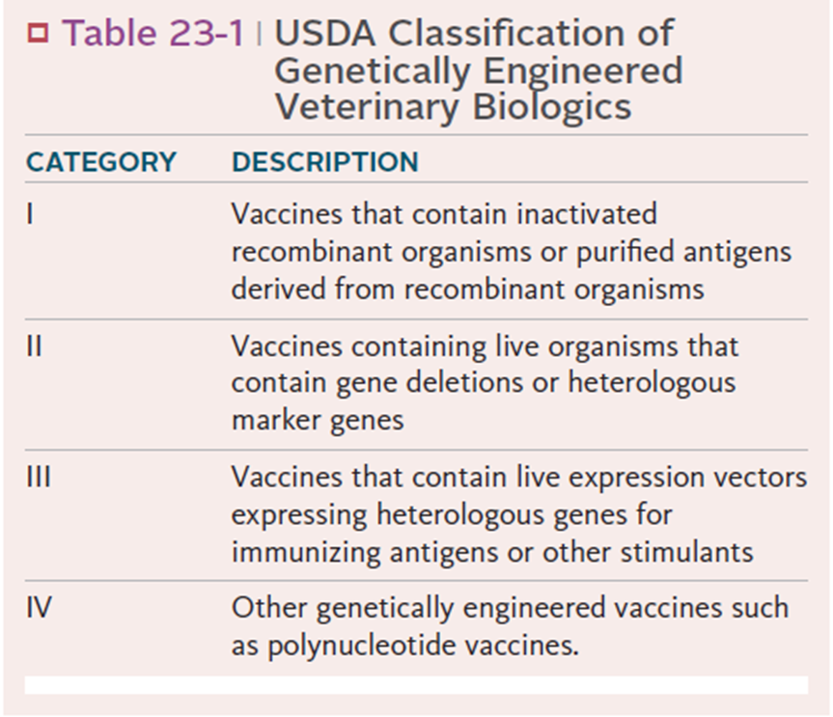

Antigens Generated by Gene Cloning (Category I)
Gene cloning can be used to produce large quantities of purified antigen in culture. In this process, DNA coding for an antigen of interest is first isolated from the pathogen. This DNA is then inserted into a bacterium or yeast in such a waythat it is functional and the recombinant antigen is expressed in large amounts.
The first successful use of gene cloning to prepare an antigen in this way involved foot-and-mouth disease virus (Figure 23-5). This virus is extremely simple. The protective antigen (VP1) is well recognized, and the genes that code for this protein have been mapped. The RNA genome of the foot-and-mouth disease virus was isolated and transcribed into DNA by the enzyme reverse transcriptase. The DNA was then carefully cut by restriction endonucleases so that it only contained the gene for VP1.
This DNA was then inserted into a plasmid, the plasmid inserted into E. coli, and the bacteria grown.
The bacteria synthesized large quantities of VP1, which was harvested, purified, and incorporated into a vaccine. The process is highly efficient since 4 × 107 doses of foot-and-mouth vaccine can be obtained from 10 L of E. coli grown to 1012 organisms per milliliter. Unfortunately, the immunity produced is inferior to that produced by killed virus and requires a 1000-fold higher dose to induce comparable protection.
The first commercially available category I recombinant veterinary vaccine was made against feline leukemia virus. The major envelope protein of FeLV, gp70, is the antigen largely responsible for inducing a protective immune response in cats.
Thus the gene for gp70 (a glycoprotein of 70 kDa) plus a small portion of a linked protein called p15e (a protein of 15 kDa from the envelope) was isolated and inserted into E. coli, which then synthesized large amounts of p70. This recombinant p70 is not glycosylated and has a molecular weight of just over 50 kDa. Once cloned, the recombinant protein is harvested, purified, mixed with a saponin adjuvant, and used as a vaccine.
Another example of a recombinant vaccine is that directed against the Lyme disease agent, Borrelia burgdorferi. Thus the
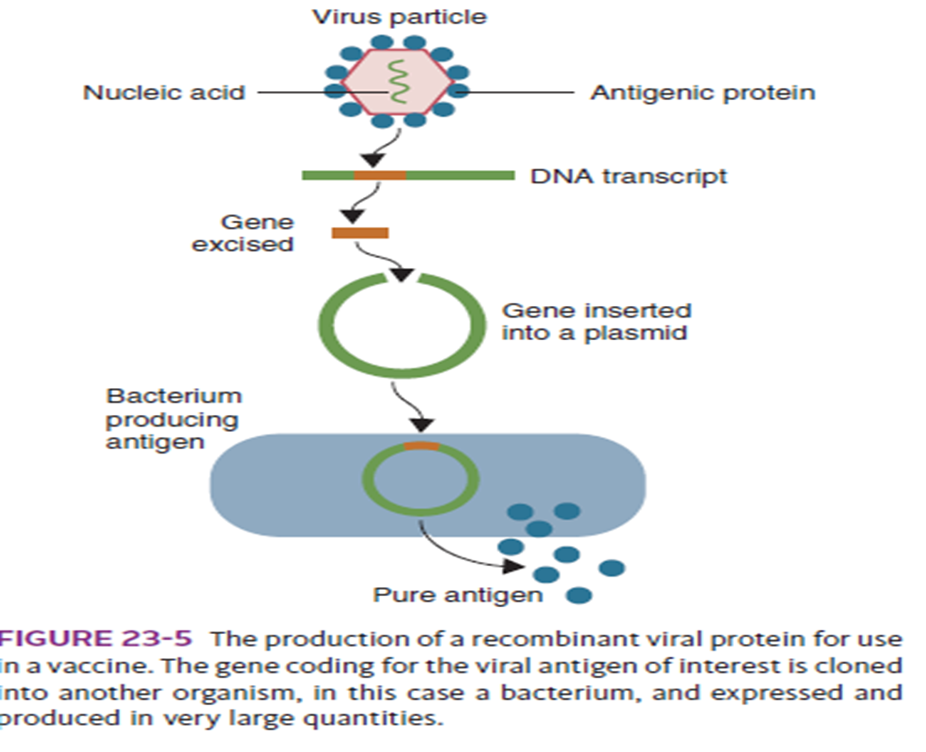

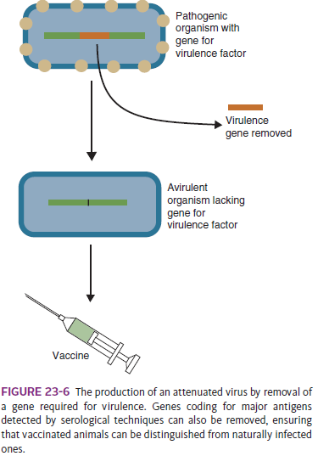
gene for OspA, the immunodominant outer surface lipoprotein of B. burgdorferi, has been cloned into E. coli. The recombinant protein expressed by the E. coli is purified and used as a vaccine when combined with adjuvant.
This vaccine is unique since ticks feeding on immunized animals ingest the antibody.
The antibodies then kill the bacteria within the tick midgut and prevent their dissemination to the salivary glands. They thus prevent transmission by the vector.
Rather than cloning the gene of interest in another microorganism, it is possible to clone vaccine antigen genes in plants.
This has been successfully achieved for viruses such as transmissible gastroenteritis, Norwalk virus, and Newcastle disease. The plants employed include tobacco, potato, soybean, rice, and corn. In some cases these plants contain very high concentrations of antigen and so can simply be fed to recipients. Although results have been mixed, a tobacco plant–based Newcastle disease vaccine has been licensed in the United States. It is unclear just how these vaccines will be best employed in animals.
Gene cloning techniques are useful in any situation in which pure protein antigens need to be synthesized in large quantities. Unfortunately, pure proteins are often poor antigens because they are not effectively delivered to antigensensitive cells and may not be correctly folded. In addition, they may be inefficient antigens because of MHC restriction.
An alternative method of delivering a recombinant antigen is to clone the gene of interest into an attenuated living carrier organism.
Genetically Attenuated Organisms (Category II)
Attenuation by prolonged tissue culture can be considered a primitive form of genetic engineering. The desired result is the development of a strain of organism that cannot cause disease.
This may be difficult to achieve, and reversion to virulence is an ever-present risk. Molecular genetic techniques, however, make it possible to modify the genes of an organism so that it becomes irreversibly attenuated.
These are classified as category II vaccines. They are available against the herpesvirus that causes pseudorabies in swine. The enzyme, thymidine kinase (TK), is required by herpesviruses to replicate in nondividing cells such as neurons. Viruses from which the TK gene has been removed can infect nerve cells but cannot replicate and cannot therefore cause disease (Figure 23-6). As a result, these vaccines not only confer effective protection but also block cell invasion by virulent pseudorabies viruses, preventing the development of a persistent carrier state.
Live Recombinant Organisms (Category III)
Genes coding for protein antigens can be cloned directly into a variety of organisms. Instead of being purified, the recombinant organism itself may then be used as a vaccine. These are classified as category III vaccines (Figure 23-7).
Experimental recombinant vaccines have used adenoviruses, herpesviruses, and bacteria such as BCG or salmonella as vectors, but the organisms that have been most widely employed for this purpose are poxviruses such as vaccinia, fowlpox, and canarypox.
These viruses are easy to administer by dermal scratching or by ingestion. They have a large stable genome that makes it relatively easy to insert a new gene (up to 10% of its genome can be replaced by foreign DNA), and they can express high levels of the new antigen.
Moreover, these recombinant proteins undergo appropriate processing steps, including glycosylation and membrane transport within the poxvirus. The avian poxviruses such as canarypox are especially effective vectors in mammals.

They do not replicate, and antigen expression only lasts about 6 hours. As a result, these vaccines are very safe, they cannot be transmitted by arthropods, and they are not excreted in body fluids. It is of interest to note that they do not stimulate immunity to the vector virus, a feature that occurs with the use of other vectors and hence can prevent subsequent immunizations. Canarypoxvectored vaccines appear in many cases to be able to overcome blocking by maternal antibodies and thus prime young animals.

They cannot revert to virulence. As a result, canarypox-vectored vaccines are widely employed for such diseases as feline leukemia, West Nile virus, canine parvovirus, canine distemper, equine influenza, and rabies. Another example of a live recombinant vaccine is vaccinia-vectored rabies. The gene for the rabies envelope glycoprotein, or G-protein, is inserted into vaccinia. This glycoprotein is the only rabies antigen capable of inducing virus-neutralizing antibody and conferring protection against rabies. Infection with this rabies-vaccinia recombinant results in the production of antibodies to the G-protein and the development of immunity.
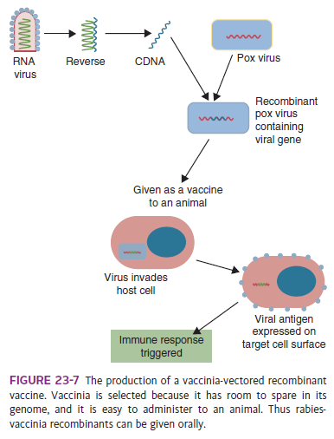

Polynucleotide Vaccines (Category IV)
Another method of vaccination involves injection, not of a protein antigen, but of DNA that encodes foreign antigens. For example, the DNA coding for a vaccine antigen can be inserted into a bacterial plasmid, a piece of circular DNA that acts as a vector (Figure 23-9).
The vaccine antigen gene is placed under the control of a strong mammalian promoter sequence. When the genetically engineered plasmid is injected intramuscularly into an animal, it will be taken up by host cells.
The DNA is then transcribed into messenger RNA and translated into endogenous vaccine protein (Figure 23-10). The plasmid, unlike viral vectors, cannot replicate in mammalian cells. Experience has shown that plasmid incorporation is enhanced by the use of some “adjuvants.” These may include lipid complexes, microcapsules, and nonionic copolymers.

Aluminum phosphate seems especially effective in improving vaccine efficiency. Transfected host cells process the vaccine
Reverse Vaccinology
Now that many complete microbial genomes are available, it is possible to identify all the proteins of a pathogen by computer analysis. This analysis can then be used to select potential protective epitopes from this repertoire.
This can lead to the identification of unique or unsuspected antigens that may then be experimentally tested—a process called reverse vaccinology (Figure 23-11).
The procedures involved include complete sequencing of the antigens of interest, followed by identification of their important epitopes, especially those that bind to common MHC molecules and are likely recognized by CD4+ and CD8+ T cells. These epitopes may be predicted by the use of computer models of the protein or by the use of monoclonal antibodies to identify critical protective components. Once identified, the protective epitopes may be chemically synthesized and tested in animals. Experimental T cell vaccines have been developed in this way against foot-and-mouth disease virus, canine parvovirus, and influenza A.

